Bo Lin

ECE 479/579 Digital Control Systems

Homework Assignment #3

1. For the system shown,

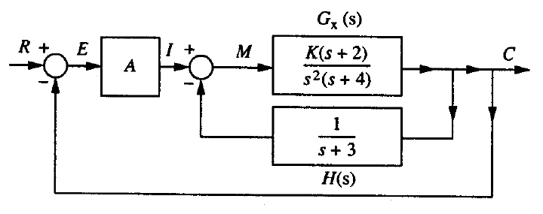

a) Find C(s)/R(s). 

b) What type of system does C(s)/R(s) represent?

Because in open loop transfer function, in the denominator, it is a S0 system, so the system is type 0.

c) Find the step, ramp, and parabolic error coefficient.



d) Find the steady-state value of c(t), e(t) and m(t) if r(t)=4u-1(t). K=1, and A=1.



e) A steady-state error less than 0.5 is required. Determine the values for A and K that meet this condition. What effect does K have on the steady-state error?



K is canceled, so K can be any value.

f) For parts d) and e) is the closed-loop system stable?



  

1. For the open-loop system



use a single lead compensation in the feedback to achieve as fast a response as possible, keeping the damping of the resonant mode better than ξ=0.05.